Installing EV Chargers for EveryBody  Ensuring Accessible Electric Vehicle Charging Stations in Maine | Guide to Locating and Installing Accessible and Usable AC Level 2 and Level 3 EV Chargers for public use.

Contents

Introduction 2
Installing Accessible Chargers 3
Location 3
Accessible Mobility Features 4
Access Aisle 5
Clear Ground Space 5
Unobstructed side reach 7
Connectors 7
Charging Cables 8
EV Chargers in the Public Right of way 8
Signage – “Use Last” Model 9
Number of Spaces 10
Maintenance 10
Conclusion 11
Checklists 12

Introduction
As the world expands the development and growth of electric vehicle (EV) infrastructure, we must ensure that we are not leaving certain populations behind. People with disabilities need to be part of this shift to electric vehicle use. Because of the speed in which EV charging stations are being installed, many public charging stations are difficult, if not impossible, to use for people with all abilities. Some conditions are beyond the installers’ ability to change. For example, the location of the vehicle inlet has not been standardized, so the vehicle may have access on the front, the back and either side of the vehicle, making standard parking difficult. There is also a need to ensure that charging allow for people who have limited reach and strength to easily used charging plugs and cords.
This document focuses on the installer of these charging systems where use by the public is intended. The guide provides information that emphasizes the physical attributes of parking accessibility, location and usage of the charging stations themselves. This guidance does not address EV installations on public right of way and/or on street parking.
This guide will create easy, understandable guidance when locating and installing EV Chargers based on US Access Board guidance. These standards will focus on AC Level 2 and Level 3 chargers. This guidance does not include on street charging stations on public rights of way.
The US Access Board sets standards for the Americans with Disabilities Act (ADA) for the use of public and private facilities, and for the Architectural Barrier Act (ABA) which applies to facilities designed, built, altered, or leased with federal funds.
Although the US Access Board does not have legal standards specifically for EV Chargers, it has numerous standards for many of the attributes of a charging station and parking requirements which are included in earlier standards. The approved ADA requirements for parking do not necessarily encompass EV parking, as they focus more on access to pedestrian facilities and less on access to charging stations. In 2022, the US Access Board released Design Recommendations for Accessible Electric Vehicle Charging Stations for installation of EV Charging stations. We have used that document to inform this Guide. The full ADA document, including on-street charger guidance can be found at: https://www.access-board.gov/tad/ev/
Various accessibility standards may apply to EV charging stations, including:
- ADA Accessibility Standards
- ABA Accessibility Standards
- Section 508 Standards

Installing Accessible Chargers
EV charging stations fall under both private and public ADA laws. Some examples of EV charging stations that may be covered under the ADA or ABA include those installed at:
- State or local government offices,
- Public parks,
- Municipal building parking lots,
- Street parking and the public right-of-way,
- Residential housing facilities provided by a state or local government,
- Public EV charging stations provided by a private entity,
- Fleet charging stations used by the federal government,
- Commercial fleet charging stations available to corporate clients, or
- Rest stops along the Interstate Highway System.

Location

When locating EV charging stations, we should access the ability to design spaces that are ADA Accessible. The accessible charger(s) shall be located where there is a level grade on multiple sides for the entire space and aisle(s). An accessible charging space shall be closest to any entrance of accessible feature, i.e. curb ramp or accessible path.
Currently there is no set requirement on how many spaces should be required but the US Access Board recommends 5% of total spaces and that 2 two of the spaces can be combined to limit the space needed for the unit. If there is only one space, that space should be accessible to ensure equal access to all users. This does not mean it needs to be exclusively for those with disabilities.
When adding charging stations to existing parking lots or new parking lots, these key conditions should be considered:
- Can the chargers be connected by a compliant accessible route to the accessible entrance of a building or facility?
- Is the slope and cross slope of the vehicle charging space less than 2.1% (1:48)?
- Can the floor or ground surface be altered to achieve slopes less than 2.1% (1:48)?
- Is there sufficient space for an 11-foot-wide, 20-foot-long vehicle space and 5-foot-wide access aisle?
- Can the chargers be placed at the same level as the vehicle charging space?
- Will existing curbs and landscaping need to be removed or altered to place chargers at the same level as the vehicle charging space?
- Can a clear floor or ground space positioned for a parallel approach with an unobstructed side reach at operable parts be provided?
- Is the clear floor or ground space firm, stable, and slip resistant?
- If EV chargers must be mounted on a curb, are operable parts of the chargers still within an unobstructed side reach and no farther than 10 inches and no higher than 48 inches above the clear floor or ground space?
- What existing site constraints are there, and would locating chargers elsewhere on the site make them more accessible?

Accessible Mobility Features
EV chargers are designed to serve people who use mobility devices and must be located on an accessible route and should provide:
- a vehicle charging space at least 11 feet wide and 20 feet long, and
- adjoining access aisle at least 5 feet wide and maximum 2.1% slopes in each direction, and
- clear floor or ground space at the same level as the vehicle charging operable parts and positioned for an unobstructed side reach, and
- accessible operable parts, including on the charger and connector.
A single unit may look like this.
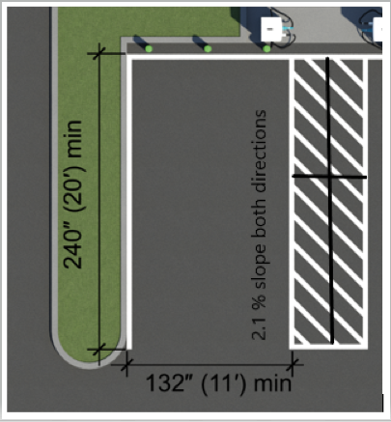
Figure 1- Access Aisle and Space, Credit: US Access Board
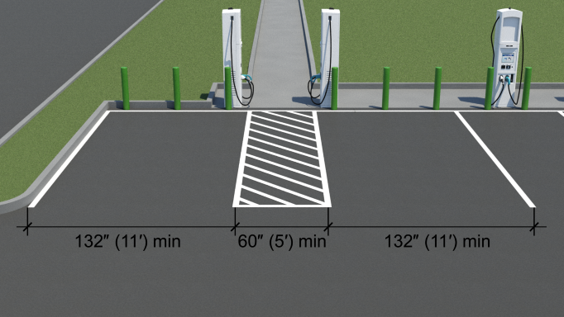
Figure 2 - Access Aisle, Credit: US Access Board

Access Aisle
The access aisle must be connected by an accessible route to the clear floor or ground space at the EV charger. The aisle should have no more than a 2.1% or 1:48 cross slope and running slope.
When charging cables are short, the charger should be positioned so that the operable parts and clear floor or ground space are on the same side as the access aisle. This configuration allows for placement of bollards to protect chargers without obstructing clear floor or ground space.

Clear Ground Space
Clear floor or ground spaces must meet requirements for ground and floor surfaces, including criteria for firmness, stability, and slip resistance. They must be free of changes in level and not sloped more than 2.1% or 1:48. Grass, curbs, wheel stops, and bollards may not be located within the clear floor or ground space.
Clear floor or ground space at chargers must be a minimum of 30 inches by 48 inches. Additional space may be required where the clear floor or ground space is confined on three sides and obstructed for more than half the depth (e.g., bollards, curbs, etc.) See Figure 3.
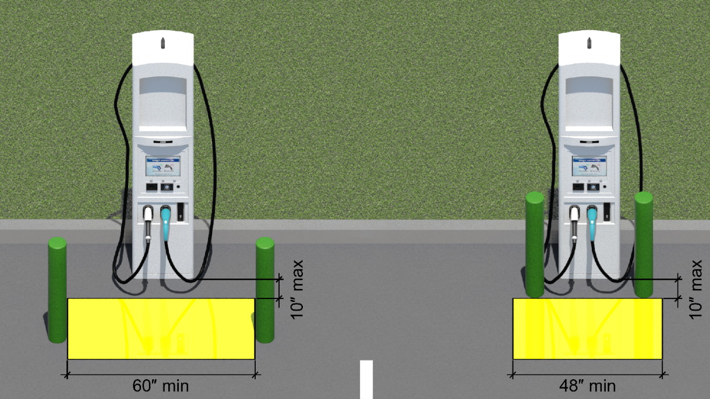
Figure 3 - Clear Grounds space, Credit: US Access Board
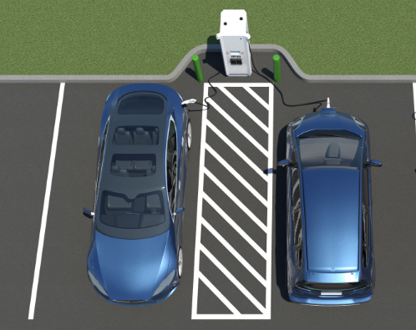
Figure 4 – Ground space with charging plugs on side of unit, Credit US Access Board
While both a forward approach and parallel approach are permitted under the ADA and ABA Standards, it is recommended that the clear floor or ground space be positioned for a parallel approach to the charger and centered on the operable part. If there are multiple operable parts, the clear floor or ground space should be centered on the EV charger.
EV chargers are highly recommended to be installed at the same level as the vehicle charging space and access aisle so that the clear floor or ground space can be placed as close as possible to the EV charger. This design ensures people who use mobility devices can readily access chargers. DO NOT DO THIS:
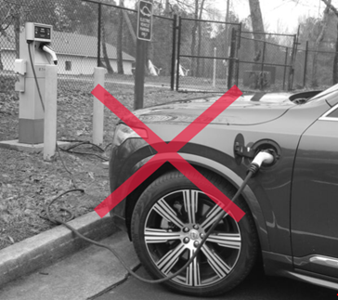
Figure 5 - Credit: US Access Board

Unobstructed side reach
All operable parts should meet the requirements for an unobstructed side reach and be no higher than 48 inches above the clear floor or ground space and no farther than 10 inches away. Placing operable parts higher than the 15-inch minimum is recommended.

Connectors
Connectors must meet the requirements for operable parts, including operation with one hand and no tight grasping, pinching, or twisting of the wrist, and no more than five (5) pounds of force to operate.
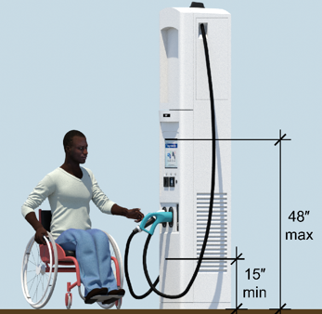
Figure 6- Connectors, Credit: US Access Board

Charging Cables
The ADA and ABA Accessibility Standards require operable parts to be operable with no more than 5 pounds of force and to not require tight grasping, pinching, or twisting of the wrist.
Light weight charging cables (AC Level 2, and some DCFCs) should be of sufficient length to charge a vehicle with various charging inlet locations.
Charging cables cannot block or obstruct accessible routes when stored or when connected to vehicles.

EV Chargers in the Public Right of way
If EV chargers must be installed on a curb, such as at on-street parking, place them as close to the edge of the face of the curb as possible and no farther than 10 inches away from the face of the curb.
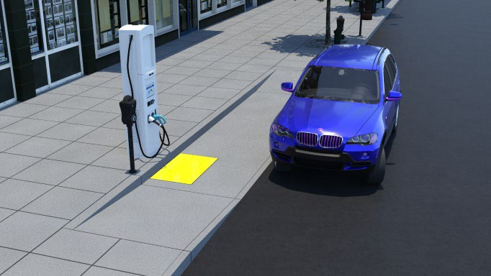
Figure 7 Credit: US Access Board
Alternatively, the EV charger and a clear floor or ground space can be placed up on the curb or sidewalk, but this design should only be used at existing curbs when it is technically infeasible to lower the curb or sidewalk. The front of the charger should not face the street or curb, and charging cables should be sufficiently long and light enough to allow mobility device users to travel back down the curb ramp and reach their vehicle charging inlet. Reaching some vehicle charging inlets may only be achievable with long charging cables, and DCFCs may be limited to charging only vehicles that have charging inlets that can be reached from the sidewalk. More information on on-street EV installations can be found at: On-Street EV Charging Stations Design)
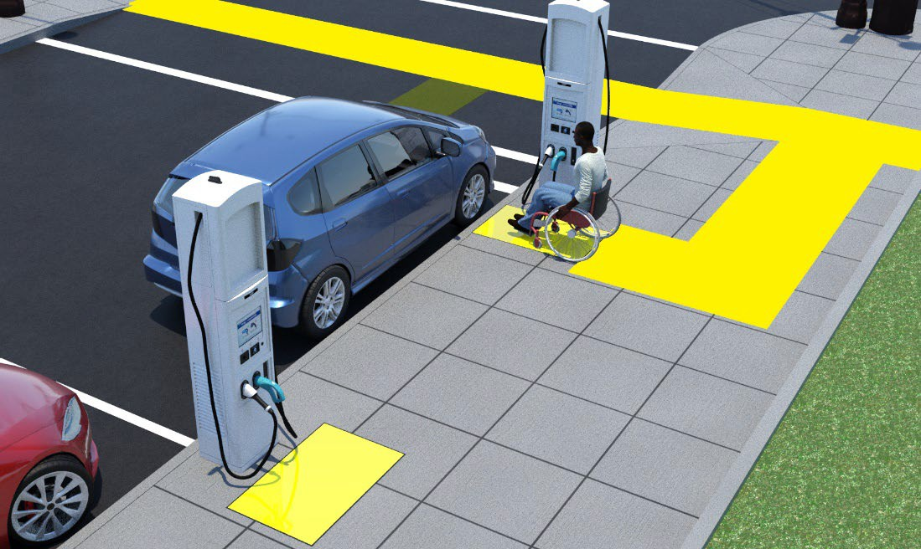
Figure 8 Credit: US Access Board
When possible, providing additional clear floor or ground space for a forward approach and turning space is recommended. Aligning the EV charger with the access aisle takes advantage of existing clear floor or ground space.

Signage – “Use Last” Model
Accessible parking spaces are identified with the International Symbol of Accessibility (ISA) and reserved for use only by a person with a disability placard or license plate. Use of the ISA at EV charging spaces causes confusion about whether people without a disability placard can use accessible EV charging spaces. Since EV charging stations usually have only a few chargers, reserving a charging space only for use by a person with a disability placard may result in underutilized chargers.
The “use last” model would not require that accessible spaces be reserved exclusively for people with disability placards. People without disability placards could use accessible EV charging spaces when all others are occupied, resulting in greater use of available chargers.
At the time of this guidance, neither Manual on Uniform Traffic Control Devices (MUTCD) nor any other code-setting organization has a standard for “use last” signs, but the Access Board has designed several examples that can be used for signage at these spaces:
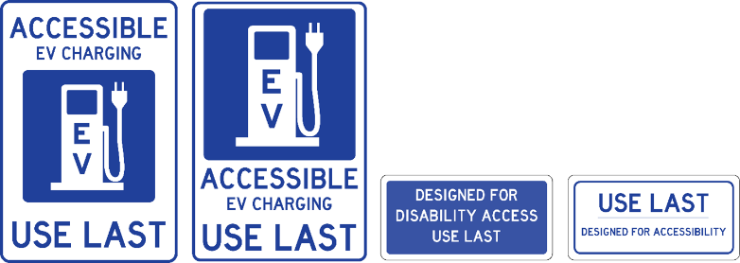
Figure 9- Sign Examples, Credit: US Access Board

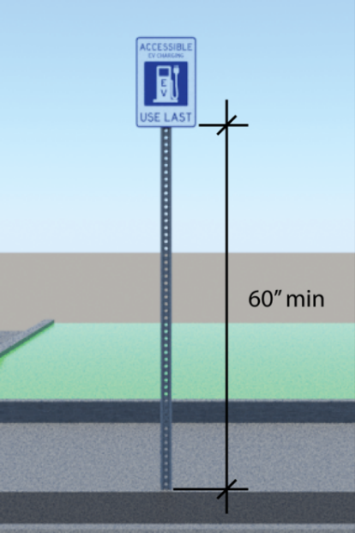
Figure 10-Sign Height, Credit: US Access Board

Number of Spaces

Five per cent but not fewer than one of electric vehicle (EV) charging spaces, in any given parking facility, must be accessible compliant. These spaces are accessible electric vehicle (EV) charging spaces, not ADA parking spaces.

Maintenance

As with all aspects of ADA compliance, EV accessible charging stations must be maintained and accessible by both public agencies and private corporations according to: CFR 28§ 35.133 and 36.211 Maintenance of accessible features. (a) A public accommodation shall maintain in operable working condition those features of facilities and equipment that are required to be readily accessible to and usable by persons with disabilities by the Act or this part. This includes any striping, pavement repair and snow removal. The aisles and approaches to the EV chargers must be firm, stable and slip resistant and striping must be maintained to clearly define the accessible parking area. The equipment must remain reachable.

Conclusion
Accessible EV charging stations will ensure that all users can fully participate in the environmental and economic advantages of this historic transition to electric vehicles. By ensuring access and considering all users, we will guarantee that people of all abilities will have equal access to this technology. As technology advances these standards may develop further, but this document is a good start to ensure that we are doing our best to accommodate users of all abilities.

Checklists
Planning for EV Stations, entities should ask questions about the feasibility of the area where EVs will be installed.
Locating EV Charging Stations in Parking Lots
Is the electricity source located or can be located to serve the accessible spaces?
Can the chargers be connected by a compliant accessible route to the accessible entrance of the building or facility?
How many EV charging stations will be created? 5% of spaces should be accessible and no less than one space should be accessible. (Not required to be exclusive.)
Is the slope and cross slope of the vehicle charging space less than 1:48 or 2.1%?
Can the floor or ground surface be altered to achieve slopes less than 1:48 or 2.1%?
Is there sufficient space for an 11-foot-wide, 20-foot-long vehicle space and 5-foot-wide access aisle?
Can the chargers be placed at the same level as the vehicle charging space? If not, will users be able to access and use the charger from the parking space lever?
Will existing curbs and landscaping need to be removed or altered to place chargers at the same level as the vehicle charging space?
Can a clear floor or ground space positioned for a parallel approach with an unobstructed side reach be provided?
If EV chargers must be mounted on a curb, are operable parts of the chargers still within an unobstructed side reach and no farther than 10 inches and no higher than 48 inches above the clear floor or ground space?
What existing site constraints are there, and would locating chargers elsewhere on the site make them more accessible?

Once the location has been determined and the parking area is being designed, ensure that these items are present (to the maximum extent feasible.)
Yes | No | Installation Checklist
 |  | Is the accessible space 11 feet wide or more?
 |  | Is the accessible space 20 feet long?
 |  | Is the accessible Aisle 5 feet wide?
 |  | Does the access aisle go directly to the charging station without obstructions?
 |  | Is the charging station at the same level as the parking space?
 |  | Is there a clear space at the Charging Station?
 |  | Is the Clear Floor or Ground Space at chargers a minimum of 30 inches by 48 inches? More when ground space is confined on 3 sides.
 |  | Is the clear Floor or Ground Space 1:48 OR 2% slope in both directions?
 |  | Are the operable parts no more than 48 inches above the ground space?
 |  | Are operable parts no more than 10 inches from the ground space?
 |  | Is the connector easily operable with one hand and with no more than 5lbs force to operate?
 |  | Do charging cables block or obstruct the accessible route when stored or connect to vehicles?
 |  | Has signage been installed for the accessible space(s)?
 |  | Is the sign no less than 60 inches from the ground?

